***International figure skating competition for single skaters***

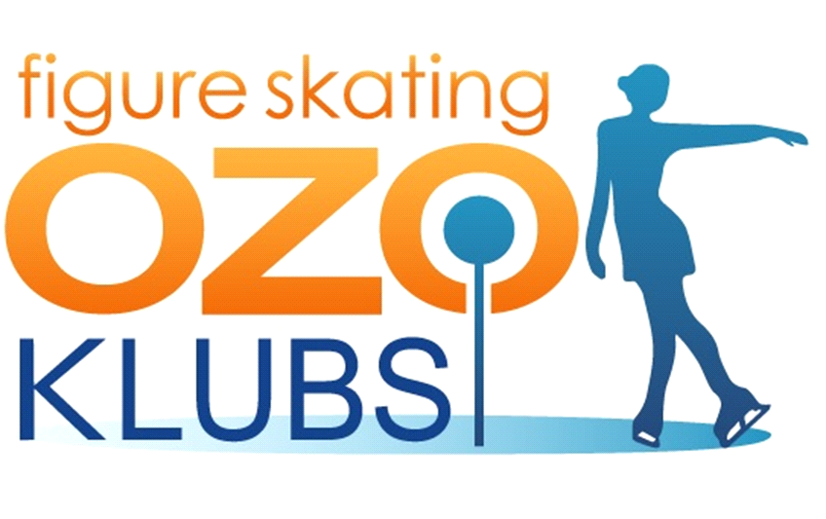

**Ozo SPRING CUP 2024**

**EVENT TIME: March 9.-10. 2024**

**ORGANIZER: OZO FSC Latvia**

**VENUE OF COMPETITION: Marupe ice hall, Kantora street 128, Marupe**

**Latvia**

***ANNOUNCEMENT***

**GENERAL:**

The OZO Spring Cup 2024 will be conducted in accordance with the ISU Constitution and General Regulations 2022, the Special Regulations & Technical Rules Single & Pair Skating and Ice Dance 2022, and the relevant ISU Communications as well as the classification of the Latvian Skating Union for season 2023/2024. Participation in the OZO Spring Cup 2024 is open to all Competitors who belong to an ISU Member, and qualify with regard to eligibility according to Rule 102, provided their ages fall within the limits specified in Rule 108, paragraph 3 a) and they meet the participation, citizenship and residency requirements in Rule 109, paragraphs 1 through 5 and ISU Communication 2526 or any update of this Communication. **ORGANIZER:**

Figure skating club “OZO”

E-mail: [ieva.pujate@gmail.com](mailto:ieva.pujate@gmail.com)

Phone number: +371 29490345

**DATE:**

9.03.2024 – 10.03.2024

**PLACE OF COMPETITION:**

Marupe ice hall, Kantora street 128, Marupe , Latvia

(an indoor ice-rink with ice surface of 28 x 56 m, air-conditioned and heated)

**ENTRIES OF COMPETITIONS:**

The attached entry forms have to be filled in precisely and can be sent by e-mail on the address given below by February 25, 2024 to:

E-mailL [ieva.pujate@gmail.com](mailto:ieva.pujate@gmail.com)

\

The deadline for entries is  **February 25. 2024**

**CATEGORIES:**

**Senior** Men, Ladies:

According to the latest ISU regulations and communications

**Junior A,B** Men and Ladies:

According to the latest ISU regulations and communications

**Advanced Novice** Boys and Girls:

According to the latest ISU regulations and communications

**Basic Novice** and **Intermediate Novice** Boys and Girls:

According to the latest ISU regulations and communications 2328

**Adult Bronze**

**Adult Silver**

**Adult Gold**

**Adult Artistic**

**Hobby Class (2007-2010)**

**Pre-Chicks A, B & C**

**Chicks A, B & C**

**Chicks Axel**

**Cubs B**

**Springs B**

**Novice B**

**Beginners 2013 and younger**

**Beginners 2011-2012**

**Beginners 2008-2010**

**Beginners 2005-2007**

**Elements A,B,C groups**

**ENTRY FEE:**

Skaters with one program – 80 EUR

Skaters with two programs - 90 EUR

Elements – 45 EUR

**Late entries –after deadline 25.02.24 + 10 EUR!**

**ENTRY FEE PAYMENT:**

Entry fees must be paid after confirmation of member participation. Bill must be paid with one (1) transaction for all the country/member participants.

The Organizer will not return entry fee

The entry fees have to be transferred to following bank account

SIA OZO DAIĻSLIDOŠANAS KLUBS  
Pampāļu iela 1-1, Rīga LV-1058  
Reg.Nr.40103685153  
CITADELE BANKA  
PARXLV22  
Acct. Nr.LV82PARX0013765130001 (EUR)

**EXPENSES:**

**Judges, Referees and Technical Panel**

The Organizer will provide accommodation and meals for all Referees, Judges drawn for the panel, Technical Controllers, Technical Specialists, Data and Replay Operators.

**Competitors** Competitors and all other Team Members are responsible for their own travel, accommodation and meal expenses.

**LIABILITY:**

In accordance with Rule 119, it is the sole responsibility of each Member participating in the competition, to provide medical and accident insurance for their athletes, officials and all other members of the Member’s team. Such insurance must assure full medical attendance and also the return to the home country by air transport or by other expeditious means of the ill or injured person.

The Organizer assumes no responsibility for or liability with respect to bodily or personal injury or property damage incurred in connection with the event mentioned above.

**THE CODE OF ETHICS:** All the skaters, coaches, judges, chaperons should follow the ISU Communication 1717, 1784 and 1853 (or any update of this Communication). Action against this rule conducts by itself the disqualification of the skater.

**MUSIC:**

All competitors shall furnish competition music of excellent quality on flash format or any other electronic media as well music could be sent in advance to e-mail.

In accordance with Rule 343 all discs must have Competitor `s name, Member`s name and the exact running time of the Music (not skating time) including any starting signal and must be submitted at the time of registration.

**PLANNED PROGRAM CONTENTS:**

With the entry forms, the “Program Content Sheet” must be returned to the Organizing Committee. ([ieva.pujate@mail.com](mailto:ieva.pujate@mail.com)),

It is mandatory that the Program Content Sheet be completed precisely by each skater in English using the proper terminology

**RESULTS:** Judging and calculations will be done according to ISU Special Regulations and

Technical Rules Single & Pair Skating and Ice Dance 2018

Result information and detailed protocols will be available on the website: [www.ozoklubs.lv](http://www.ozoklubs.lv)

**AWARDING:**

The three best-placed competitors in each event will be awarded with a medal. All competitors will receive a diploma.

**DRAWING:**

Draw will be done electronically on **8.03.2024.** Starting orders will be available at the webpage [www.ozoklubs.lv](http://www.ozoklubs.lv)

There will be no draw for the free skating, Advanced Novices, Junior, Senior .The start list will be in opposite order.

**TIMETABLE:**

Detailed time schedule will be published at the webpage [www.ozoklubs.lv](http://www.ozoklubs.lv)

soon after the close of entries.

**ACCOMODATION:**

The Organizer will make the room arrangements for INVITED officials only.

Skaters, coaches and other team members can book accommodation themselves.

**Recommended Hotels:**

**Hampton by Hilton RigaAirpot**

**Address: Priezkalni A, Marupes novads, Riga, LV-2167, Latvia**

## Rixwell Elefant Hotel

**Address:****Kalnciema iela 90, Rīga, LV-1046, Latvia**